|  |  |
| --- | --- |
| **DATE** | 07.11.2022 |
| **TEAM ID** | PNT2022TMID44916 |
| **PROJECT NAME** | CRUDE OIL PRICE PREDICTION |

INSTALLATION OF PYTHON 3.7.4

STEP 1: Type python in google and click on the first link.

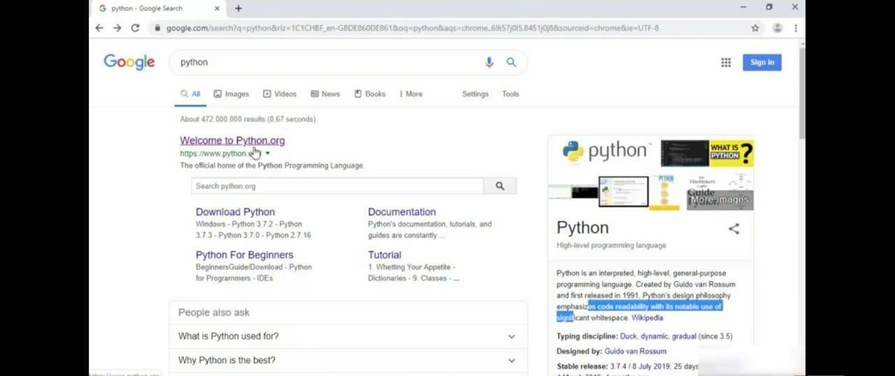

STEP 2: Click the python 3.7.4

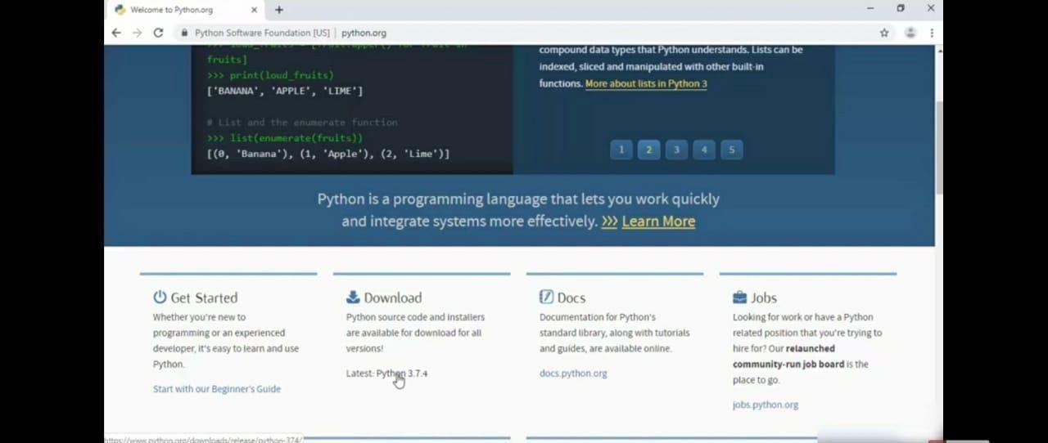

STEP 3: Scroll down to reach the Files and click windows x86-64 executable installer.

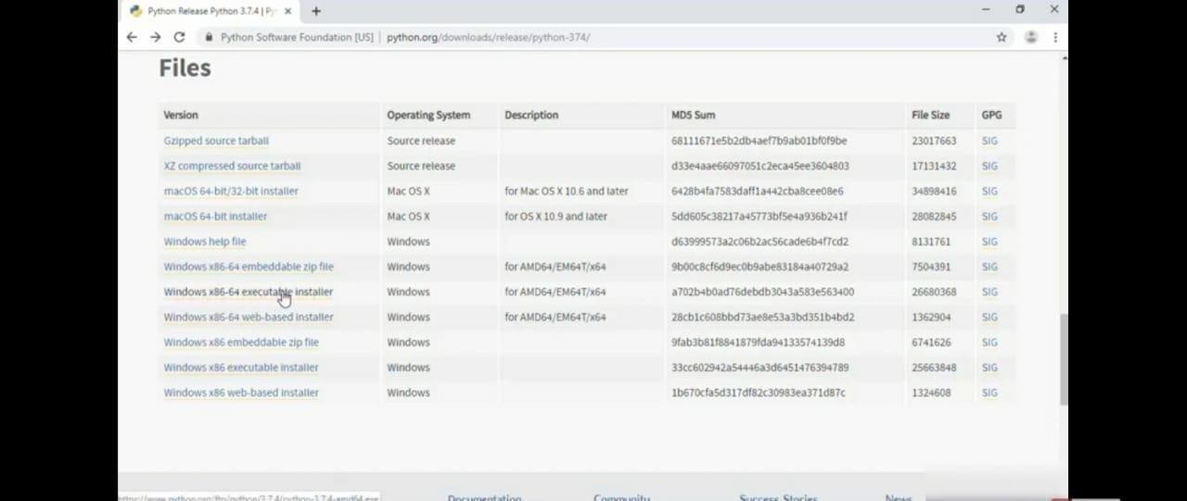

STEP 4: Click on the executable file.

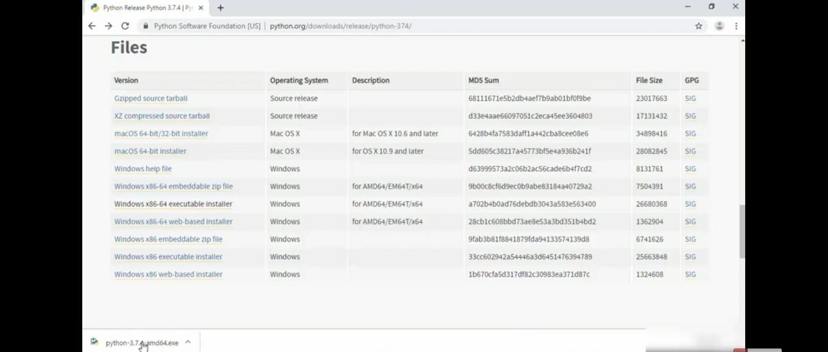

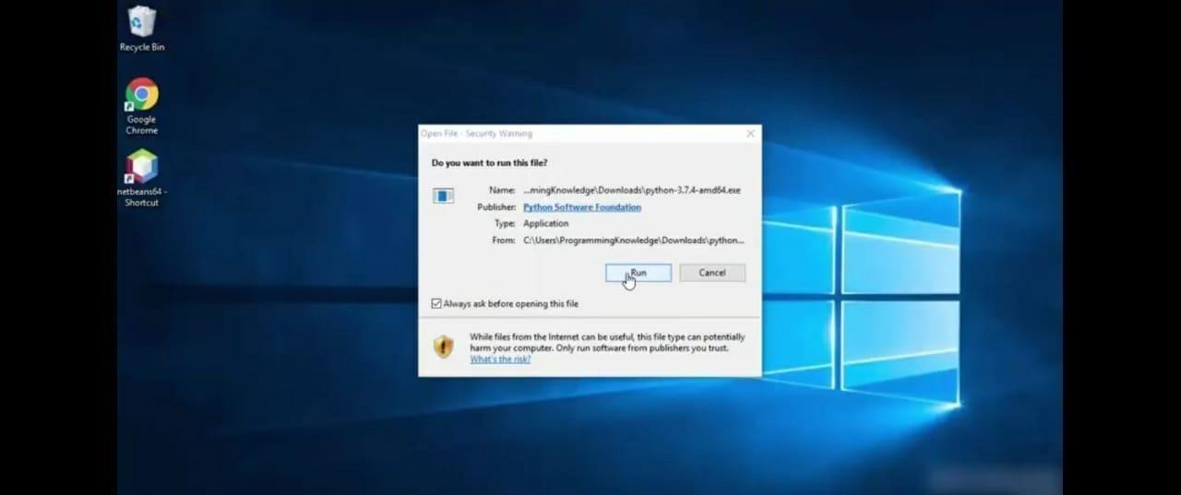

STEP 6: To change the path click on the second check box Add python 3.7 to PATH and then click the customize installation.

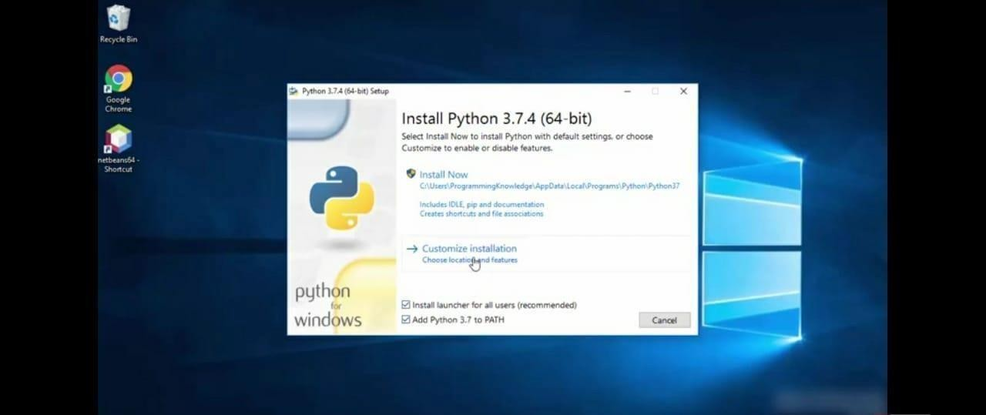

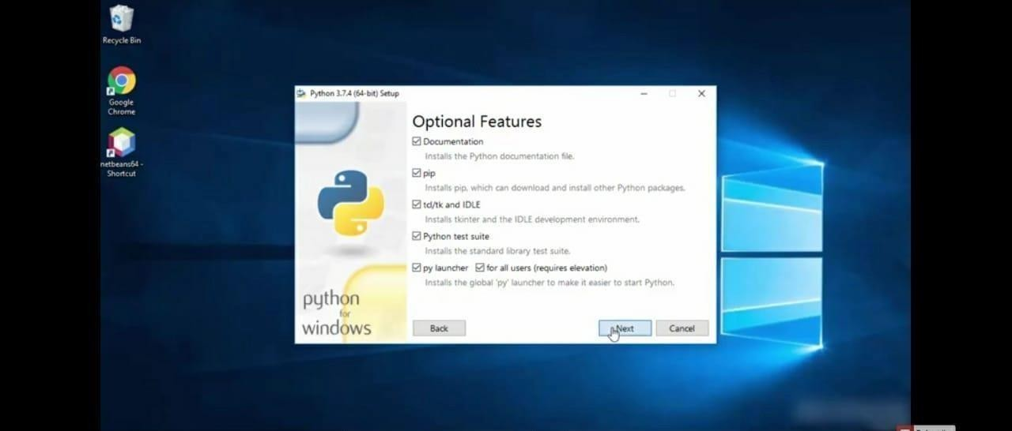

STEP 8: You can change the path here and click on the install button.

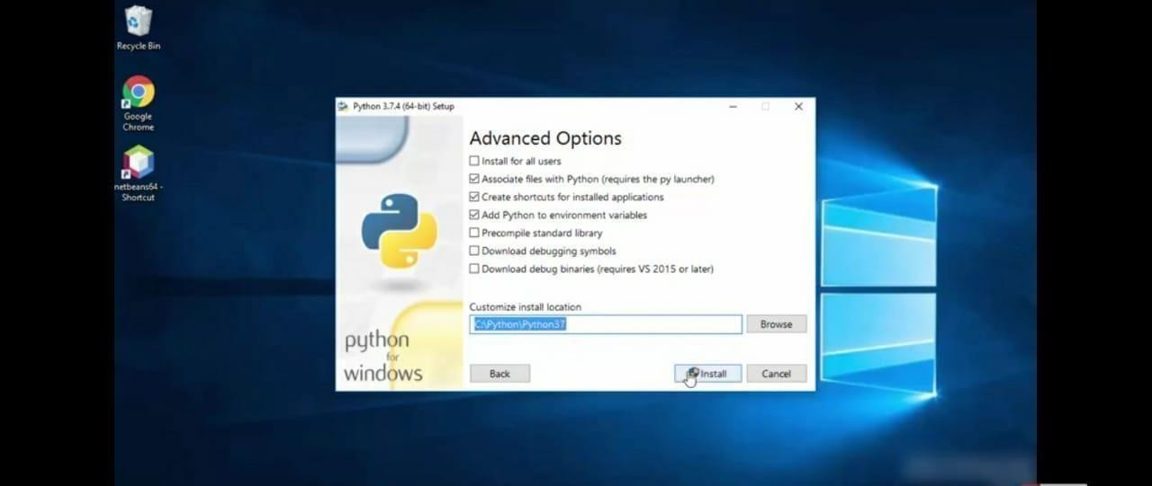

STEP 9: Installation process.

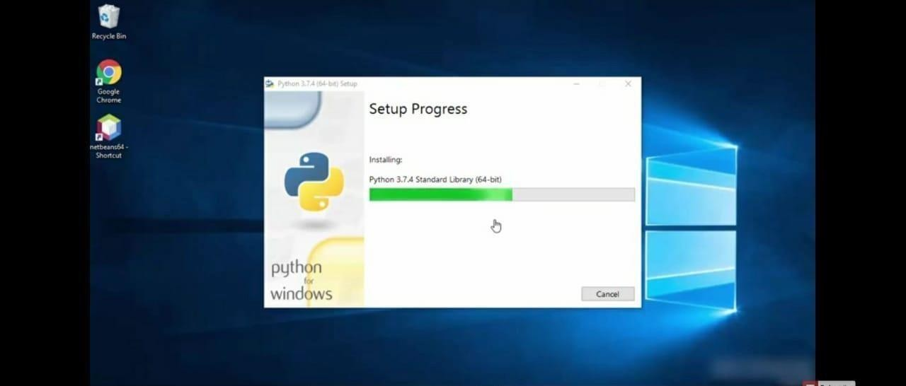

STEP 10: Click Yes button.

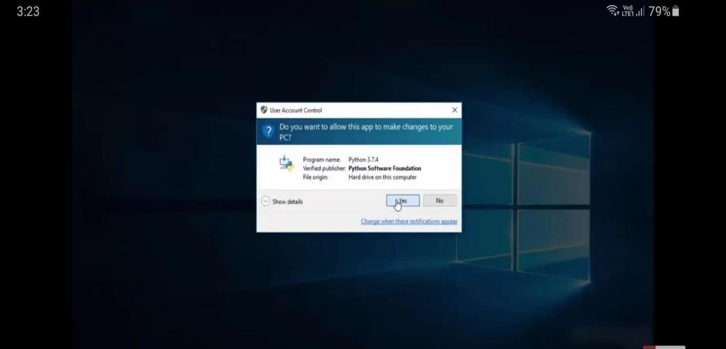

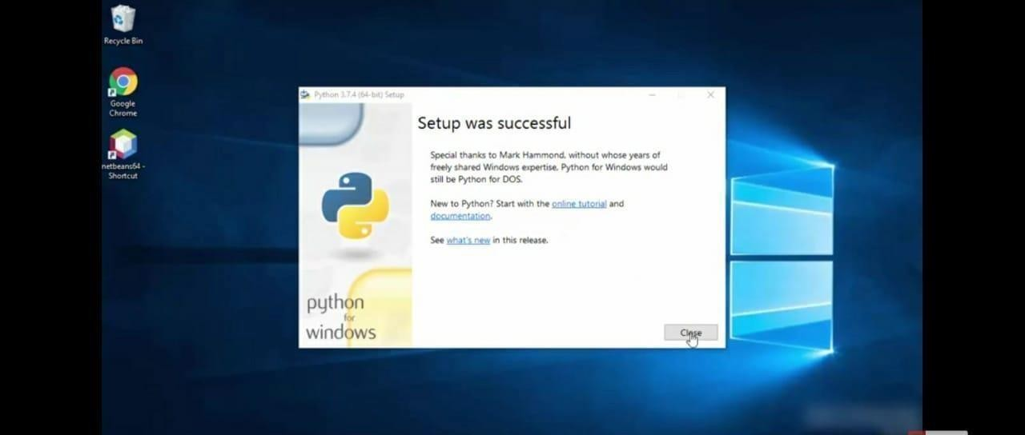

STEP 12: To check whether it is working click the windows icon , click the All apps.

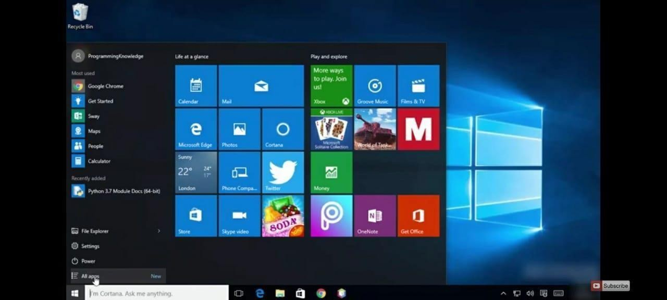

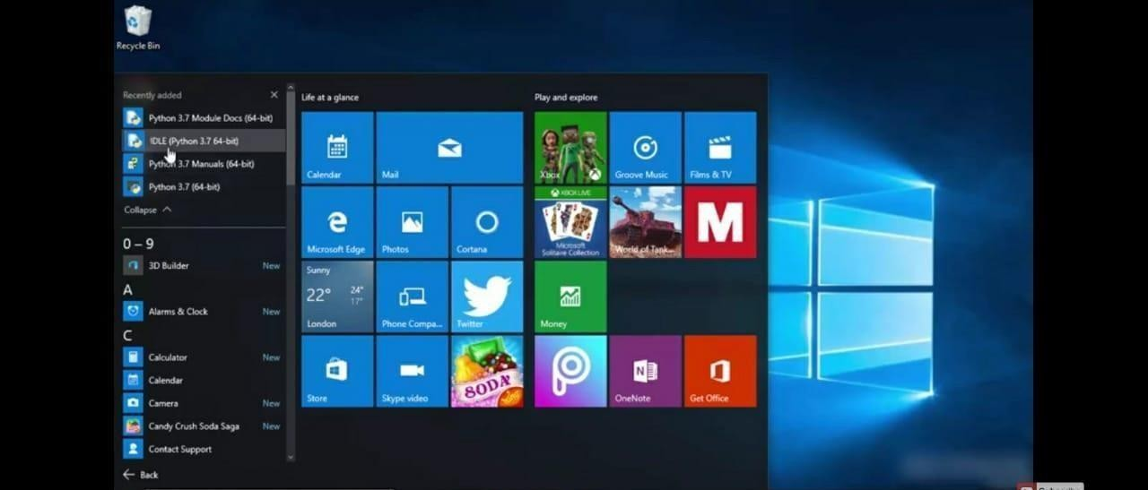

STEP 14: This is the IDLE window.

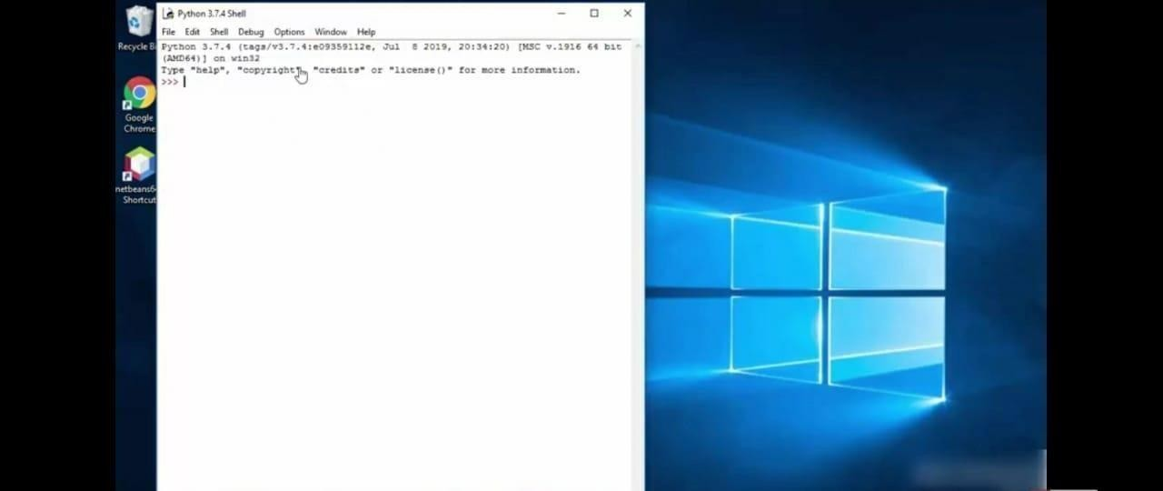

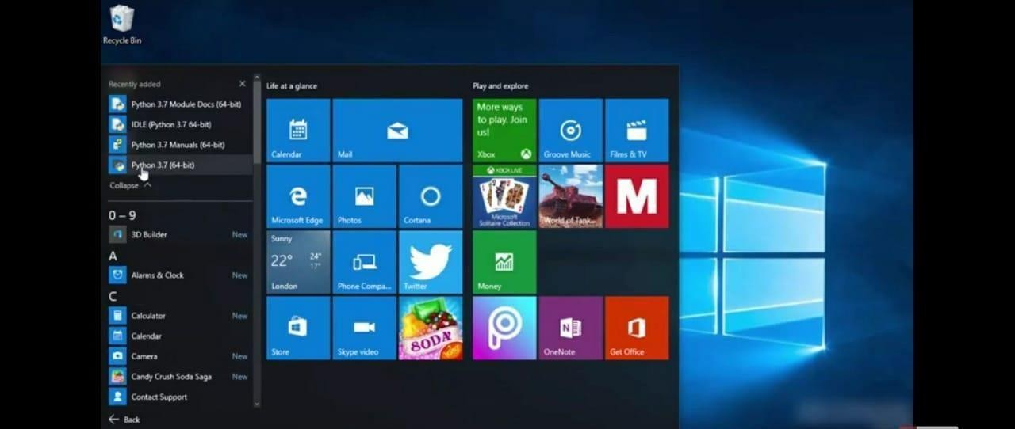

STEP 16: This is the Python 3.7 (64-bit) command prompt.

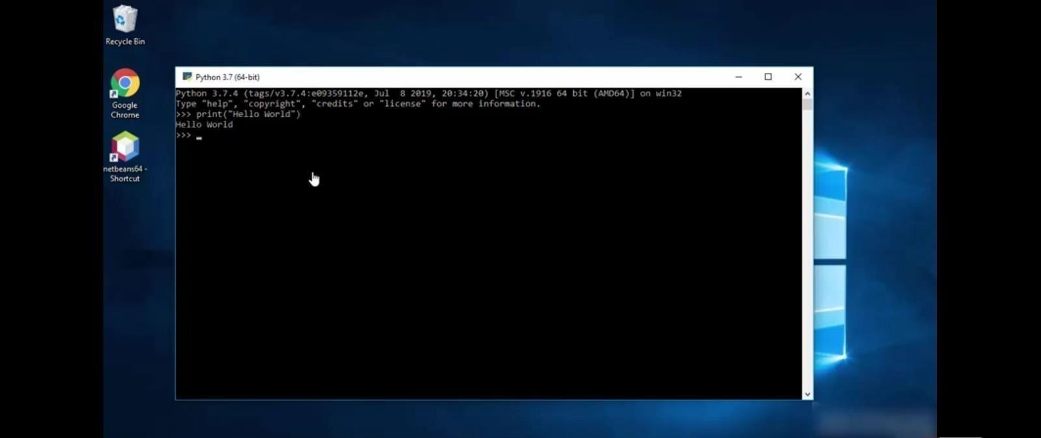

windows icon.

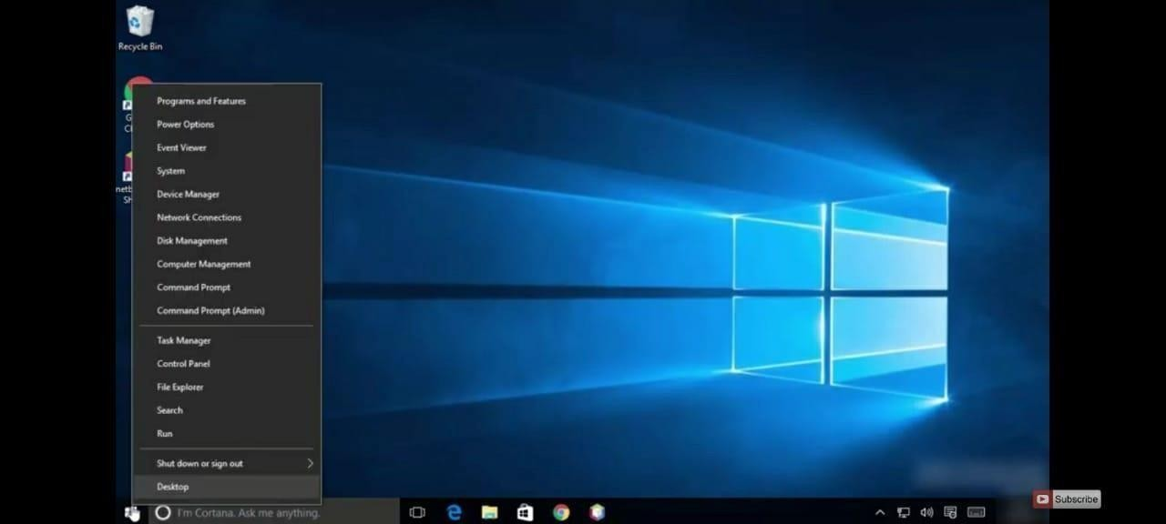

STEP 18: Click the command prompt.

